2020 In the latest ranking conducted by the Times, the most prestigious international ranking system of the world's universities, the Faculty of Engineering and Technology of Shahrekord University is ranked among the best in the world in the range of 401-500.

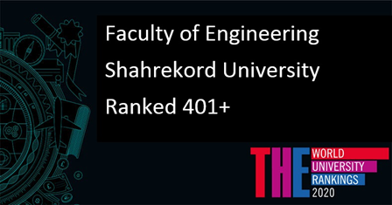

2021 Shahrekord University is among the most effective universities in the top one percent of the world according to the latest list of basic science indicators (ESI) owned by Clarity Analytics (ISI), Shahrekord University was ranked 1001-1526 out of 1526 universities in the 2021 ranking of this database.

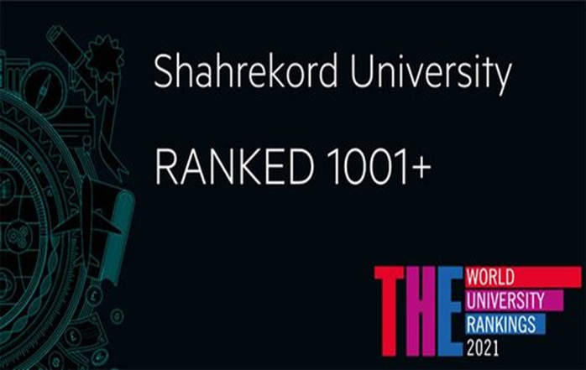

2022 The latest ranking of the Times World Ranking Database was published in 2022, and Shahrekord University, for the third year in a row, was ranked 1001-1201 among 1662 universities in the world that were eligible to enter this ranking system.

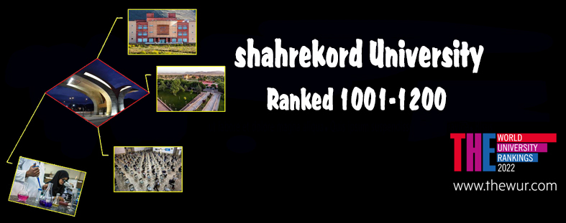

Seven faculty members of Shahrekord University were included in the list of 2% of the world's top scientists based on the list published by the Scopus Institute in 2021:

- Dr. Behzad Ghasemi Full Professor, Engineering Fluid Mechanics,
- Dr. Yaghoub Tadi Bani, Full Professor, Engineering Solid Mechanics,
- Dr. Ahmadi Nodooshan, Associate Professor, Engineering Fluid Mechanics
- Dr. Yaser Kiani, Associate Professor, Engineering Solid Mechanics, Faculty of Engineering,
- Dr. Mehdi Ghasemi Varnamkhastai, Bio-system Mechanics, Faculty of Agriculture
- Dr. Fayez Raeis Gahrouei, Full Professor, Soil Science and Engineering- Faculty of Agriculture
- Dr. Azizollah Fallah Mehr Jerdi Associate Professor, Food Hygiene and Quality Control - Faculty of Veterinary Medicine.



