Memorandum of Understanding and International Contracts

List | The Name of the Organ | Date of Contract | The Name of the Organ of the Opposite Party
1 | 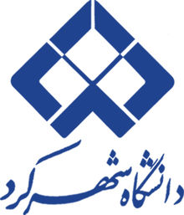  Shahrekord University, Iran | October, 2017 | 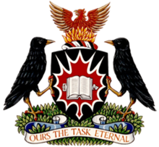  Carlton University, Canada
2 | Shahrekord University, Iran | November, 2017 | 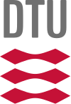  University of Technology, Denmark
3 | Shahrekord University, Iran | June, 2017 |   University of Ghent, Belgium
4 | Shahrekord University, Iran | February, 2018 | 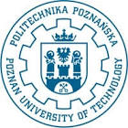  University of Poznan, Poland
5 | Shahrekord University, Iran | November, 2018 | 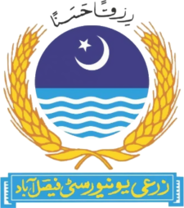  Faisalabad Agricultural University, Pakistan
6 | Shahrekord University, Iran | April, 2018 | 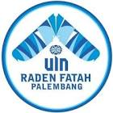  Raden Fath University, Indonesia
7 | Shahrekord University, Iran | October, 2018 | 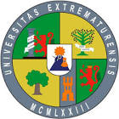  University of Extremadura, Spain
8 | Shahrekord University, Iran | June, 2018 | 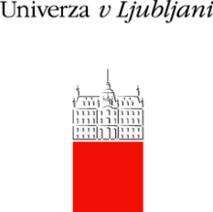  University of Ljubljana, Slovenia
9 | Shahrekord University, Iran | July, 2018 | 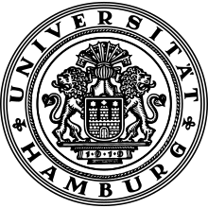  University of Hamburg, Germany
10 | Shahrekord University, Iran | June, 2019 |   Allegro University, Portugal
11 | Shahrekord University, Iran | December, 2020 | Carlton University, Canada (extended)
12 | Shahrekord University, Iran | November, 2020 | 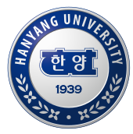  Han Yang University, South Korea
13 | Shahrekord University, Iran | January, 2021 | 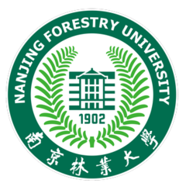  Nanjing Forestry University, China

